Business Name & Logo Test Workbook
Your Name as the Business Owner(s):

In your activity packet on the bottom of page two, you described a business that you would open if you could. Describe here what the at business would be and the products you would sell.

Is your product a good, a service or both?

Why do you think it is important to provide products that customers want and need?
The first step to owning a beginning and owning business is to market the business by creating a Business Name and Creating a Logo that people can easily recognize and say. Complete the following sections to create a business Name and Logo in and effort to market and brand your company.

- Complete and watch the Ed Puzzle on How to Name your Business on Google Classroom and fill out the sheet below as you watch it.

Step 1: Make it Original. As a new business, you want to compel people to
you. Original means don’t be afraid to . The video describes 4 ways to come up with a Creative Name that is original. Define the four ways list in the list below:

- Generate a bunch of Names -
- Explore Key Words – Explain what it means from the video
- Read Books or Articles
- Play it UP

Step 2: Make it Future Proof: Describe what it means to be Future proof

Step 3: Make it User Friendly Describe what it means to be user friendly

Use word two words to name your business

Step 4: Make Sure It’s Available: Describe what this means and why it is important:

Where are some locations to check if your name is available?

Do you think it will be important to have your product or service as part of your company name?

Step 5: Make sure you love it. Describe why you think this would be important.

Part 1: Name your Business
You Try it. From the business you described you would open (question 1 on page 1), you will generate a business name that will follow the four steps described in the video.

1: Generate a List of Key words for your type of business in the space below:

- Generate a list of possible names you would use for your business. List at least 10 different names.

- Before settling on a business name, make sure you have done the following: What name are you thinking about ? Test it as follows:

- Do an internet search for the name and see what other businesses come up. We want to avoid choosing the same name as an existing business, particularly in your area. What did you find out when you searched the name you choose above:

- Run it by a few friends and classmates. Is it clear what your business does or do you have to explain? Detail and explain what happened when you tested this on your classmates?

- Check to see if the business name is available as a username on the most common social media sites. Example Creative Impressions is what I call my business. When I search it as a .com site does another business already have this? Test this explain what you learned?

Note:
- Ideally, your domain name matches your company name. If the ‘.com’ domain name is taken, you might opt for a .org or .net domain, although studies show that people tend to trust .com domains
- When looking up your business for the first time, they are also most likely to assume that your business is under a .com domain name, and if they can’t find you that way, they may give up searching altogether

If you think you are ready, then answer the following:

- What is the name of your business?

- What made you decide on this name?

Sign up to create a Business Logo
The logo for your business needs to be a digital design that is unique to your business. You are encouraged to find inspiration online. You will use Canva to create a logo for your business. You must sign into the Link to the Intro to Business Class in google classroom. If you do not select this you will not have access to all the Education Features available in Canva. Be sure you show your class in Canva.

Go to Google classroom in the stream section and select the link as shown below:

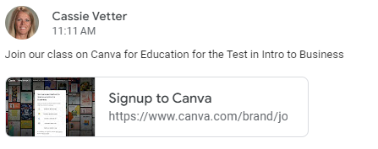

Business Logo
- Review the information on our class website “Create a Logo Presentation”. You can also read the article at https://blog.hubspot.com/marketing/how-to-design-logo. Answer the following questions:

                - Define what a Logo is:

                - What is the Purpose of a Logo?

                - Give 3 reasons why Logos are important.

                - There are 7 types of Logos. Read each, look at the few examples in the presentation. Now list two or three that would be interesting for you to create a logo for your business.

                - Color is important in the design of your logo. What colors would you consider and why? Choose two colors

                - Fonts can create a positive message of your business. Look at the types of fonts slide and view the many graphic examples. Looking at the many fonts used in the examples, what is your impression? List two you like and why.

                - What is the Number 1 best practice when developing your logo?

Brainstorm and Sketch an Idea of why you want your logo to look like. Nothing perfect, just a general Idea in the space on this page.
Business Name:

Business Logo
- Go to Canva and Create a Logo for your business. Be sure you signed up for the Class hour for Intro to Business and Marketing class as there are many free features you can use to create your logo.
- Your logo may include your business name or elements suggesting the industry you are in, but it is completely up to you.
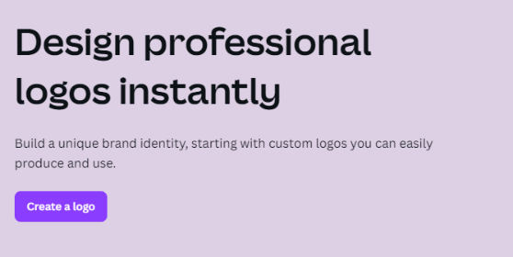
- Your logo may end up on a variety of color backgrounds or even textures/materials. Start with a solid white background, but then see what it looks like with other color backgrounds too. Go to Canva, select Logos from the Marketing Menu. Select Create a Logo from the Design professional logos menu.

- Use the Elements page of Canva to create headings, font, colors, add graphics etc/

- Submit the Canva Version by selecting “Turn Into Techer”. In the upper right Corner
- Download your graphic as a .jpg version
- Submit into Google Classroom as an attachment. To do this select share, download, and change the File type to .jpg or .png. It will download to your downloads file or to your Google Drive. Attach to the google classroom assignment.

